**UBER TRIP ANALYICS QUERIES**

* See all the data imported:

1. SELECT *FROM [Uber Trip Details]
2. SELECT *FROM [Location Table]

**QUERY PROBLEMS:**

1. **Total Booking**

SELECT

'$' + CAST (CAST (COUNT ([Trip_ID]) / 1000.0 AS DECIMAL (10, 2)) AS VARCHAR (20)) + ' K' AS Total_Bookings

FROM [Uber Trip Details];

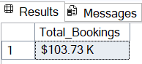

1. **Total Booking Value**

SELECT

'$' + CAST (CAST (SUM (fare_amount + [Surge_Fee]) / 1000000 AS DECIMAL (10, 2)) AS VARCHAR (20)) + ' M'

AS Total_Booking_Value

FROM [Uber Trip Details];

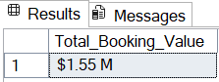

1. **Avg Booking Value**

SELECT

'$' + CAST (CAST (AVG (fare_amount + [Surge_Fee]) AS DECIMAL (10, 2)) AS VARCHAR (20))

AS Avg_Booking_Value

FROM [Uber Trip Details];

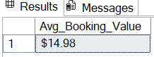

1. **Total Trip Distance**

SELECT CONCAT (CAST (SUM (trip_distance)/1000 AS decimal (10, 2)), ' K miles') AS Total_Trip_Distance

FROM [Uber Trip Details];

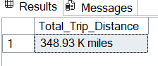

1. **Avg Trip Distance**

SELECT CONCAT (CAST (AVG (trip_distance) AS decimal (10, 2)), ' K miles') AS Avg_Trip_Distance

FROM [Uber Trip Details];

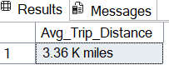

1. **Avg Trip Time**

SELECT

CAST (AVG (DATEDIFF (MINUTE, [Pickup_Time], [Drop_Off_Time])) AS DECIMAL (10, 1)) AS Avg_Trip_Time_Minutes

FROM [Uber Trip Details];

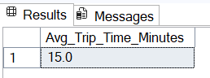

1. **Total Booking by Payment Type**

SELECT Payment_type, COUNT (Trip_ID) AS Total_Booking_by_Payment_Type

FROM [Uber Trip Details]

GROUP BY Payment_type

ORDER BY Total_Booking_by_Payment_Type DESC;

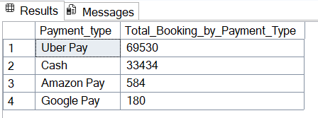

1. **Total Booking Value by Payment Type**

SELECT

Payment_type,

'$ ' + CAST (CAST (SUM (fare_amount + [Surge_Fee]) AS DECIMAL (10, 1)) AS VARCHAR (20)) AS Total_Booking_Value_by_Payment_Type

FROM [Uber Trip Details]

GROUP BY Payment_type

ORDER BY SUM (fare_amount + [Surge_Fee]) DESC;

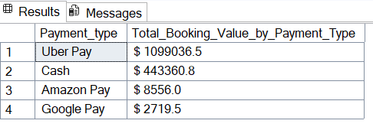

1. **TOTAL BOOKING BY TRIP(DAY/NIGHT)**

SELECT

CASE

WHEN DATEPART (HOUR, [Pickup_Time]) BETWEEN 6 AND 16 THEN 'Day'

ELSE 'Night'

END AS Trip_Shift,

CAST (CAST (COUNT ([Trip_ID]) * 100.0 / SUM (COUNT ([Trip_ID])) OVER () AS DECIMAL (5, 2)) AS VARCHAR (10)) + ' %'

AS Booking_Percentage

FROM [Uber Trip Details]

GROUP BY

CASE

WHEN DATEPART (HOUR, [Pickup_Time]) BETWEEN 6 AND 16 THEN 'Day'

ELSE 'Night'

END

ORDER BY Booking_Percentage DESC;

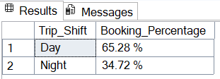

1. **TOTAL BOOKING VALUE BY TRIP(DAY/NIGHT)**

SELECT

CASE

WHEN DATEPART (HOUR, [Pickup_Time]) BETWEEN 6 AND 16 THEN 'Day'

ELSE 'Night'

END AS Trip_Shift,

'$ ' + CAST (CAST (SUM (fare_amount + [Surge_Fee]) AS decimal (10, 2)) AS VARCHAR (20)) AS Total_Booking_Value

FROM [Uber Trip Details]

GROUP BY

CASE

WHEN DATEPART (HOUR, [Pickup_Time]) BETWEEN 6 AND 16 THEN 'Day'

ELSE 'Night'

END

ORDER BY Total_Booking_Value DESC;

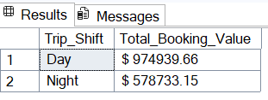

1. **Top 5 Pickup Locations by Total Bookings.**

SELECT TOP 5

L.Location,

COUNT (U.[Trip_ID]) AS Total_Bookings

FROM [Uber Trip Details] U

JOIN [Location Table] L

ON U.PULocationID = L.LocationID

GROUP BY L.Location

ORDER BY Total_Bookings DESC;

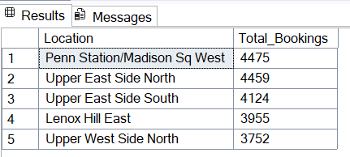

1. **Top 5 Drop Locations by Total Bookings.**

SELECT TOP 5

L.Location,

COUNT (U.[Trip_ID]) AS Total_Bookings

FROM [Uber Trip Details] U

JOIN [Location Table] L

ON U.DOLocationID =L.LocationID

GROUP BY L.Location

ORDER BY Total_Bookings DESC;

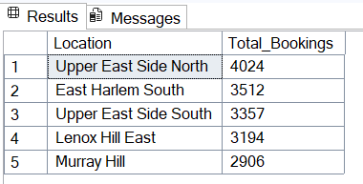

1. **Top 5 Drop Locations by Revenue**

SELECT TOP 5

L.Location,

'$ ' + CAST (CAST (SUM (U.fare_amount + U.Surge_Fee) AS DECIMAL (10, 2)) AS VARCHAR (20)) AS Total_Revenue

FROM [Uber Trip Details] U

JOIN [Location Table] L

ON U.DOLocationID = L.LocationID

GROUP BY L.Location

ORDER BY SUM (U.fare_amount + U.Surge_Fee) DESC;

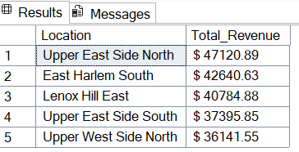

1. **Revenue Contribution by City in %**

SELECT

L.City,

CONCAT (

CAST (

(SUM (U.fare_amount + U.Surge_Fee) * 100.0) /

(SELECT SUM (fare_amount + Surge_Fee) FROM [Uber Trip Details])

AS DECIMAL (5, 2)

), ' %'

) AS Revenue_Contribution_Percentage

FROM [Uber Trip Details] U

JOIN [Location Table] L

ON U.DOLocationID = L.LocationID

GROUP BY L.City

ORDER BY Revenue_Contribution_Percentage DESC;

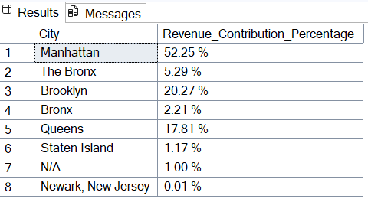

1. **Most Frequently Used Payment Type by Location**

WITH PaymentCounts AS (

SELECT

L.Location,

U.Payment_type,

COUNT (U. [Trip_ID]) AS Total_Bookings,

ROW_NUMBER () OVER (PARTITION BY L.Location

ORDER BY COUNT (U. [Trip_ID]) DESC) AS rn

FROM [Uber Trip Details] U

JOIN [Location Table] L

ON U.PULocationID = L.LocationID

GROUP BY L.Location, U.Payment_type

)

SELECT

Location,

Payment_type AS Most_Used_Payment_Type,

Total_Bookings

FROM PaymentCounts

WHERE rn = 1

ORDER BY Total_Bookings DESC;

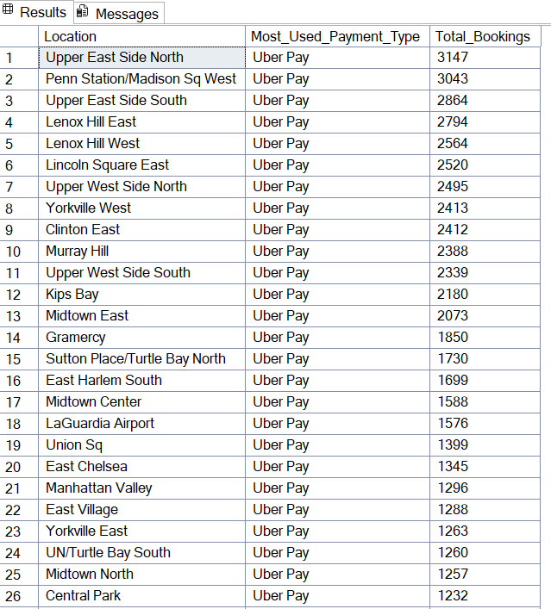

1. **Total Booking Hours of Days**

SELECT

DATEPART (HOUR, Pickup_Time) AS Booking_Hour,

COUNT ([Trip_ID]) AS Total_Bookings

FROM [Uber Trip Details]

GROUP BY DATEPART (HOUR, Pickup_Time)

ORDER BY Booking_Hour;

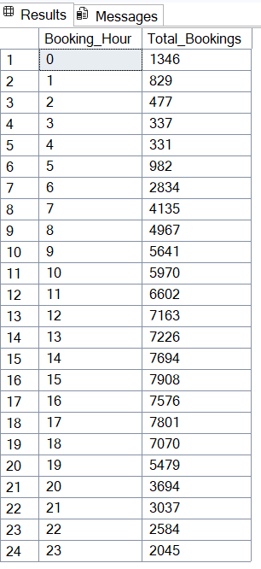

1. **Total Bookings by Day of Week**

SELECT

DATENAME (WEEKDAY, Pickup_Time) AS Booking_Day,

COUNT ([Trip_ID]) AS Total_Bookings

FROM [Uber Trip Details]

GROUP BY DATENAME (WEEKDAY, Pickup_Time), DATEPART (WEEKDAY, Pickup_Time)

ORDER BY DATEPART (WEEKDAY, Pickup_Time);

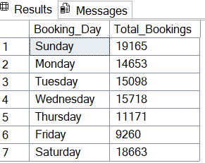

1. **Average Fare per K miles**

SELECT

CAST (SUM (fare_amount) / SUM (Trip_Distance) AS DECIMAL (10, 2)) AS Avg_Fare_Per_KM

FROM [Uber Trip Details];

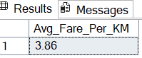

1. **Trips with Surge Pricing**

SELECT

COUNT (CASE WHEN Surge_Fee > 0 THEN 1 END) AS Trips_With_Surge,

COUNT (*) AS Total_Trips,

CAST (

(COUNT (CASE WHEN Surge_Fee > 0 THEN 1 END) * 100.0 / COUNT (*))

AS DECIMAL (5, 2)

) AS Surge_Percentage

FROM [Uber Trip Details];

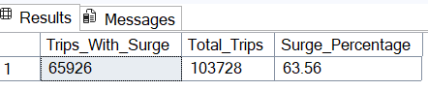

1. **Highest Surge Fee Paid in a Trip**

SELECT CONCAT ('$ ', CAST (MAX (Surge_Fee) AS decimal (5, 1))) AS Highest_Surge_Fee_Paid

FROM [Uber Trip Details];

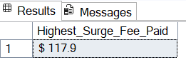

1. **Top 10 Longest Trips by Distance**

SELECT TOP 10

Trip_ID,

trip_distance,

fare_amount,

(fare_amount + Surge_Fee) AS Total_Fare,

CAST (Pickup_Time AS DATE) AS Pickup_Date,

CAST (Pickup_Time AS TIME) AS Pickup_Time,

CAST (Drop_Off_Time AS DATE) AS Drop_Date,

CAST (Drop_Off_Time AS TIME) AS Drop_Time

FROM [Uber Trip Details

ORDER BY trip_distance DESC;

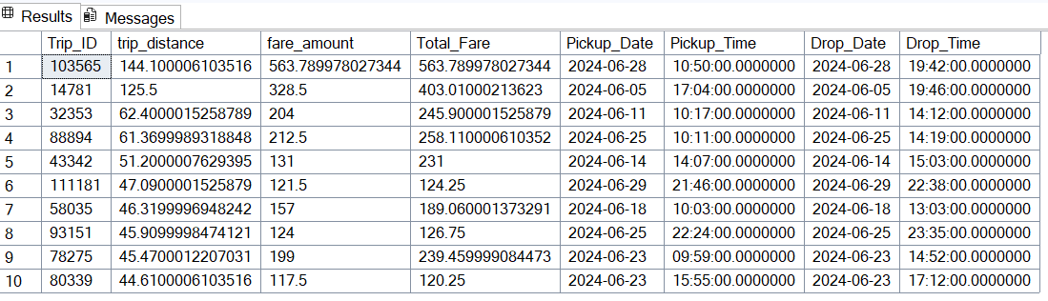

1. **Top 10 Longest Trips by Time**

SELECT TOP 10

Trip_ID,

FORMAT (DATEADD (MINUTE, 330, Pickup_Time), 'HH:mm: yyyy’) AS Pickup_Date_IST,

FORMAT (DATEADD (MINUTE, 330, Drop_Off_Time), 'HH:mm: yyyy’) AS Drop_Date_IST,

DATEDIFF (MINUTE, Pickup_Time, Drop_Off_Time) AS Trip_Duration_Minutes,

CAST (trip_distance AS DECIMAL (10, 1)) AS Trip_Distance_Miles,

CAST ((fare_amount + Surge_Fee) AS DECIMAL (10, 1)) AS Total_Fare

FROM [Uber Trip Details]

ORDER BY DATEDIFF (MINUTE, Pickup_Time, Drop_Off_Time) DESC;

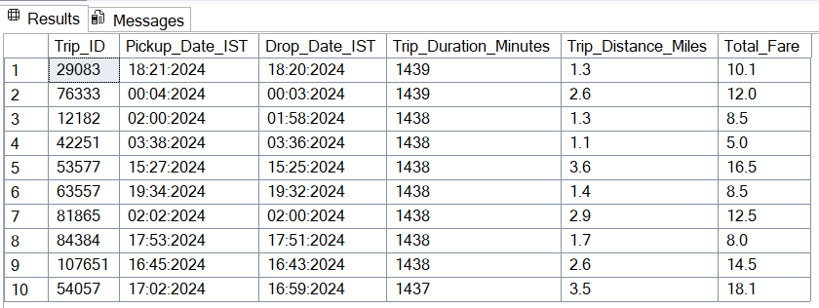

1. **Bookings Distribution by Weekday vs Weekend**

SELECT

CASE

WHEN DATEPART (WEEKDAY, Pickup_Time) IN (1, 7) THEN 'Weekend' -- Sunday (1) & Saturday (7)

ELSE 'Weekday'

END AS Day_Type,

COUNT (Trip_ID) AS Total_Bookings,

CONCAT (CAST (ROUND (COUNT (Trip_ID) * 100.0 / SUM (COUNT (Trip_ID)) OVER (), 1) AS DECIMAL (5, 1)), '%')

AS Booking_Percentage

FROM [Uber Trip Details]

GROUP BY

CASE

WHEN DATEPART (WEEKDAY, Pickup_Time) IN (1, 7) THEN 'Weekend'

ELSE 'Weekday'

END;

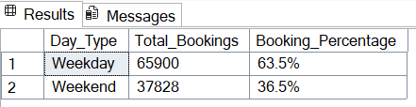

1. **Weekday vs Weekend – Average Revenue per Trip:**

SELECT

CASE

WHEN DATEPART (WEEKDAY, Pickup_Time) IN (1, 7) THEN 'Weekend' -- Sunday (1) & Saturday (7)

ELSE 'Weekday'

END AS Day_Type,

COUNT (Trip_ID) AS Total_Trips,

CONCAT ('$ ', CAST (SUM (fare_amount + Surge_Fee) AS DECIMAL (10, 2))) AS Total_Revenue,

CAST (AVG (fare_amount + Surge_Fee) AS DECIMAL (10, 2)) AS Avg_Revenue_Per_Trip

FROM [Uber Trip Details]

GROUP BY

CASE

WHEN DATEPART (WEEKDAY, Pickup_Time) IN (1, 7) THEN 'Weekend'

ELSE 'Weekday'

END;

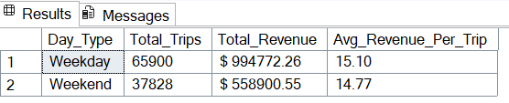

1. **Bookings per Vehicle Type**

SELECT Vehicle,

COUNT (Trip_ID) AS Total_Bookings,

ROUND (COUNT (Trip_ID) * 100 / SUM (COUNT (Trip_ID)) OVER (), 1) AS Booking_Percentages

FROM [Uber Trip Details]

GROUP BY Vehicle

ORDER BY Total_Bookings DESC;

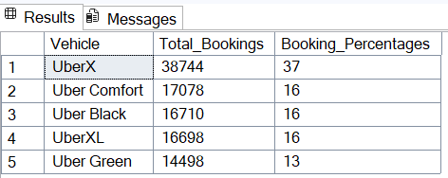

1. **Total Trip Distance by Vehicle Type**

SELECT

Vehicle,

CONCAT (CAST (SUM (trip_distance) AS DECIMAL (10, 1)), ' K miles') AS Total_Trip_Distance

FROM [Uber Trip Details]

GROUP BY Vehicle

ORDER BY SUM (trip_distance) DESC;

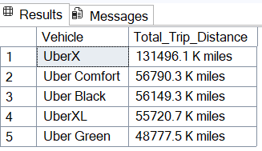

1. **Top 5 Locations Generating Highest Revenue**

SELECT TOP 5

L.Location,

CONCAT ('$ ', CAST (SUM (U.fare_amount + U.Surge_Fee) AS DECIMAL (10, 1))) AS Total_Revenues

FROM [Uber Trip Details] U

JOIN [Location Table] L

ON U.PULocationID = L.LocationID

GROUP BY L.Location

ORDER BY SUM (U.fare_amount + U.Surge_Fee) DESC;

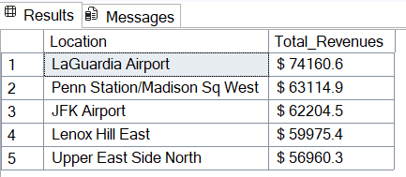

1. **Top 5 Peak Hours by Bookings Count.**

SELECT TOP 5

DATEPART (HOUR, Pickup_Time) AS Pickup_Hour,

COUNT (Trip_ID) AS Total_Bookings

FROM [Uber Trip Details]

GROUP BY DATEPART (HOUR, Pickup_Time)

ORDER BY Total_Bookings DESC;

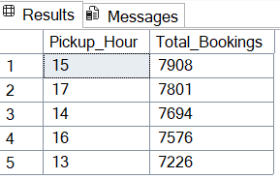

1. **Calculate Average Speed per Trip (Distance / Time)**

SELECT

Trip_ID,

CAST(trip_distance / NULLIF(DATEDIFF(MINUTE, Pickup_Time, Drop_Off_Time) / 60.0, 0) AS DECIMAL(10,2)) AS Avg_Speed_MPH

FROM [Uber Trip Details]

ORDER BY Avg_Speed_MPH DESC;

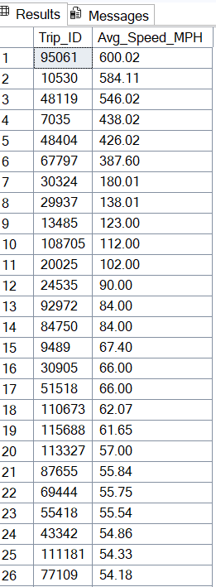

1. **Top 3 Cites Generating Highest Revenue**

SELECT TOP 3

L.City,

CONCAT('$ ', CAST(SUM(U.fare_amount + U.Surge_Fee) AS DECIMAL(10,1))) AS Total_Revenues

FROM [Uber Trip Details] U

JOIN [Location Table] L

ON U.PULocationID = L.LocationID

GROUP BY L.City

ORDER BY SUM(U.fare_amount + U.Surge_Fee) DESC;

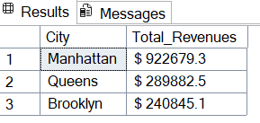

*******END*******